Microsoft logo

Robotic Process Automation in a Day

Lab 4 – Integrate with cloud flows (create machine connection)

60 mins

May 2023

Applies to Power Automate Desktop v. 2.31.105.23101 ([more](https://learn.microsoft.com/en-us/power-platform/released-versions/power-automate-desktop))



This document is provided “as-is.” Information and views expressed in this document, including URL and other Internet Web site references, may change without notice. You bear the risk of  
using it. Some examples are fictitious and are for illustration only. No real association is intended  
or inferred. This document does not provide you with any legal rights to any intellectual property in any Microsoft product. You may copy and use this document for your internal reference purposes.

© 2021 Microsoft Corporation. All rights reserved.

Lab Overview

You will complete the following tasks in this lab:

* Create a new Solution to package the end-to-end invoice processing solution and required connection references
* Create a cloud flow
* Configure machine connection to enable the cloud flow to execute the desktop flow on your device
* Add the “Enter invoice with input” desktop flow to this new cloud flow
* Perform a test run of the new cloud flow

Prerequisites

This lab builds on the previous labs – ensure all tasks are complete.

**Note**: If you have registered your machine with Lab 1.3 steps, you should be good to go. In such case, just take a look at the steps below to ensure, you’re machine is registered properly.

Manage machines

Machines are the physical or virtual devices that are used to automate your desktop processes. When you connect your machine to Power Automate, you can you can instantly start your desktop automation using any of the wide array of [available triggers](https://docs.microsoft.com/en-us/power-automate/triggers-introduction), such as when you receive an e-mail or on a pre-defined scheduled.

Connecting your machine directly to Power Automate and the cloud allows you to harness the full power of your robotic process automation (RPA). The easiest way to connect your machine to the cloud is with our direct connectivity. All you need to do is ensure that you installed and signed into the latest version of Power Automate Desktop, and your machine will be registered with Power Automate automatically. Once registered, you can create a connection right away in your cloud flows.

Register a new machine

**Note:** this is covered in pre-requisite #1.3. Your machine should have already been registered on the currently selected environment in the application.

## Create a solution and connection references

1. Open the test profile in a browser and navigate to <https://make.powerautomate.com/>.
2. Next navigate to the **Solutions**.

1. Click **New solution**.

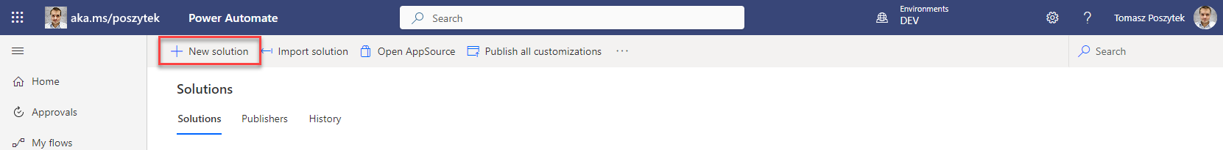

1. Use the following values:
   1. Display name: Invoice processing solution <MyUserName>
   2. Name – leave as generated
   3. Publisher – click New publisher and provide the following values:
      1. Display name – your name and lastname
      2. Name – leave as generated
      3. Prefix – use your initials, just letters
      4. Choice value prefix – leave as is
      5. Click **Save**
   4. Version – leave as is
   5. Click **Create**

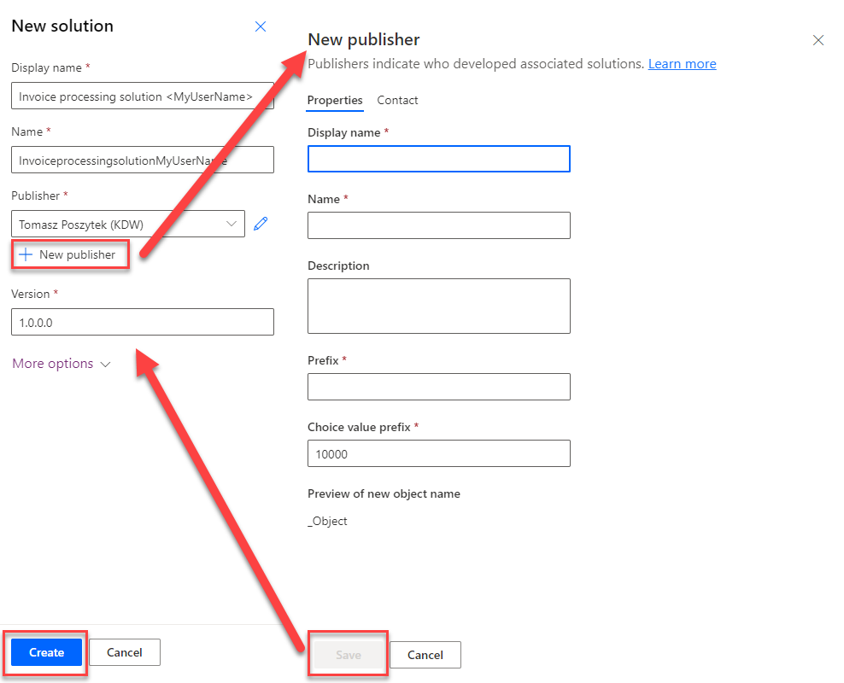

1. After the solution is created, you will now add desktop flow created in lab 3 to the solution. To do that, click **Add existing**, then **Automation**, and then **Desktop flow**.

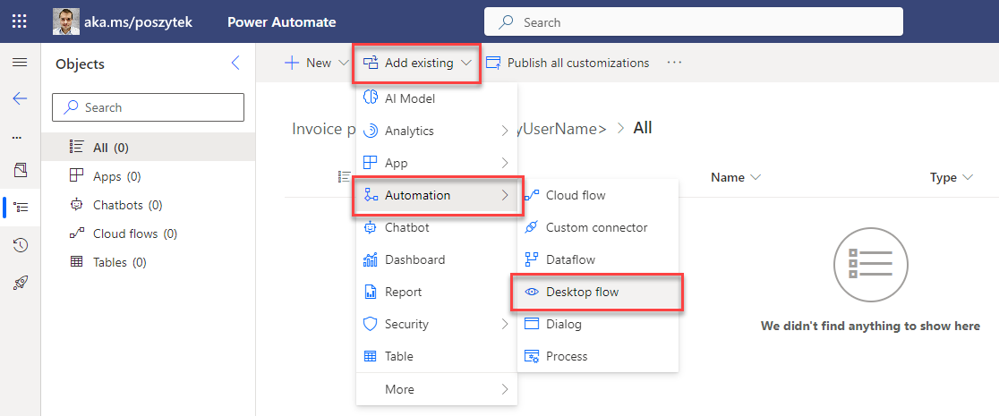

1. Select the **Enter an invoice** desktop flow and click **Add** button.

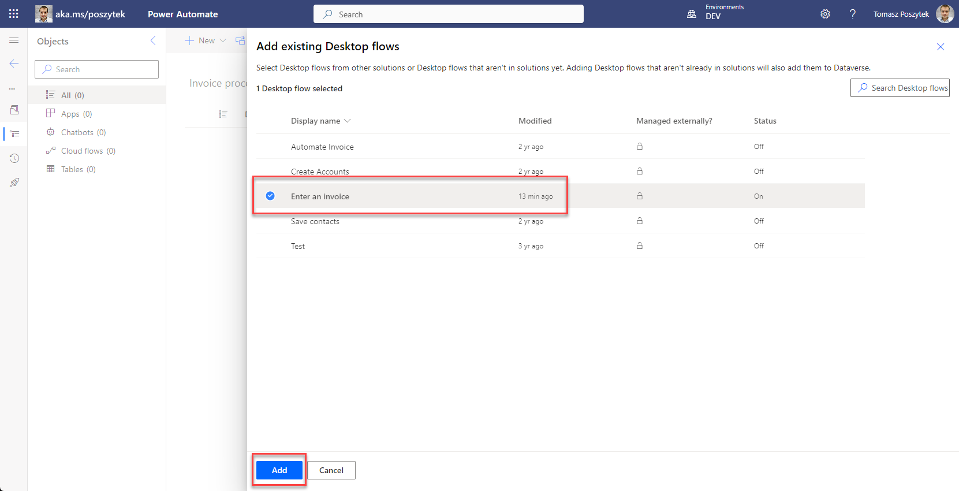

1. Now you need to create a couple of connection references, to handle future automation scenarios that are described in this training.

**Note:** to learn more about connection references, follow the link below:

<https://learn.microsoft.com/en-us/power-apps/maker/data-platform/create-connection-reference>

You will create the following connection references:

* 1. Desktop flows
  2. Office 365 Outlook
  3. Microsoft Teams
  4. Microsoft Dataverse

1. First, create the desktop flow connection reference. To do that, click New 🡪 More 🡪 Connection Reference.

1. Use the following information:
   1. Display name – **desktop flow conn**
   2. Name – as generated
   3. Connector – select Desktop flows
   4. Connection – click New connection

1. A new tab will open, where you need to provide details for the new connection. In the displayed modal window, configure fields with the following settings:
   1. **Connect** - select Directly to machine
   2. **Machine or machine group** – select the machine you have registered in lab 1.3
   3. **Domain** and username – the account used to sign in to the machine
   4. **Password** – the password of the account used to sign in to the machine

**Note**: If you are not sure what to put in the Domain and username field, you can use the Command Prompt window (open Start, type CMD and hit enter), type “**Set user**” command to locate the Domain and Username. Fill in the textbox with **USERDOMAIN\USERNAME**.

**Tips**: to make sure you have the correct login credentials. You can try log out the computer and use the username/password combination to see if you can successfully log into this computer.

**Important:** In order for the account to be able to create the connection it must be granted the “Desktop Flows Machine User” or “Environment user” environment security role: <https://docs.microsoft.com/en-us/power-automate/desktop-flows/manage-machines#update-permissions-based-on-security-role>.

1. Click Create.

1. You can now close the tab and return to the one with the solution. Hit refresh, select the created connection and hit Create button.

1. Next, repeat the same steps for the remaining connection references to: Office 365 Outlook, Microsoft Teams and Microsoft Dataverse:
   1. Click **New** 🡪 **More** 🡪 **Connection Reference**
   2. Set **Display name** to <connector name> conn, eg. Office 365 Outlook conn
   3. Leave **Name** as generated
   4. Under the **Connection** click **New connection** and set up the connection in the new tab.
   5. After a connection is created, close the new tab, return to the one with the solution.
   6. Hit **Refresh** button above the **Connection** field, select the created connection and hit **Create** button.

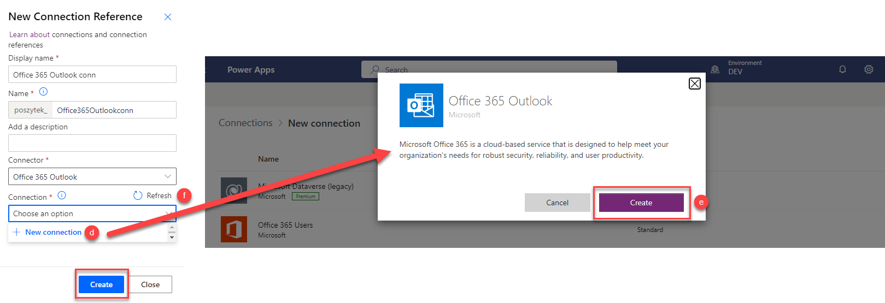

1. After all the connection references are created, your solution should contain the following elements:

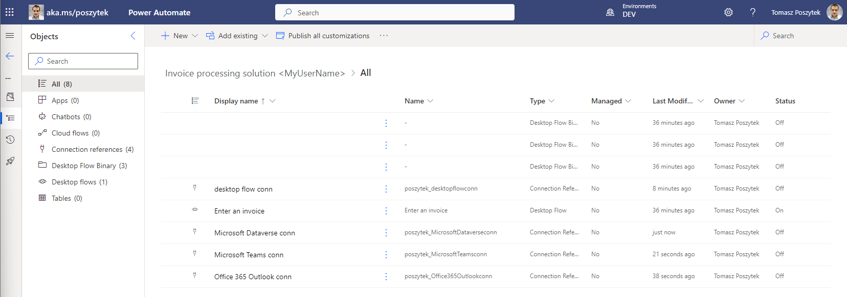

## Trigger a desktop flow to run on your machine

**Note:** To use this functionality, you have to own a paid or a trial of [**premium per-user plan with attended RPA**](https://docs.microsoft.com/en-us/power-automate/desktop-flows/manage-machines). (If you have done lab 1.1 pre-requisite, you should already have a premium trial

1. Open the test profile in a browser and navigate to <https://make.powerautomate.com/>.
2. Navigate to solutions.
3. Select the solution **Invoice processing solution <MyUserName>** created earlier in this lab.

1. Select New 🡪 Automation 🡪 Cloud flow 🡪 Instant

1. Name the flow Manual trigger desktop flow to enter invoice, choose Manually trigger a flow. Then select Create.

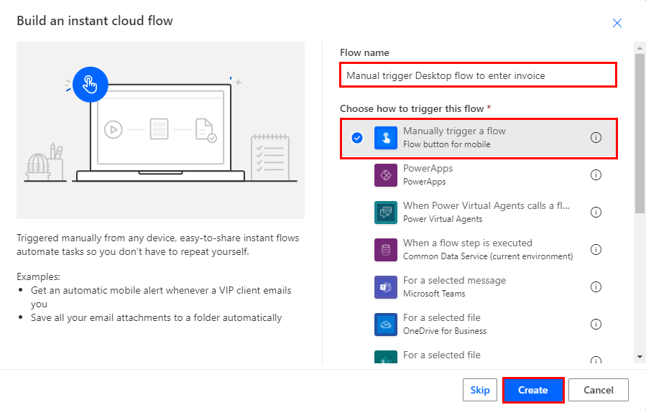

1. Add a step by clicking + New step.

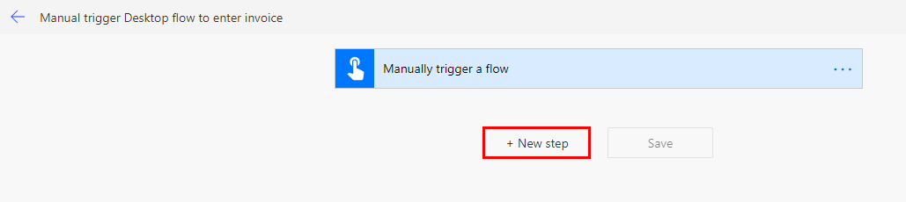

1. Enter desktop flow in the search box and choose Desktops flows.

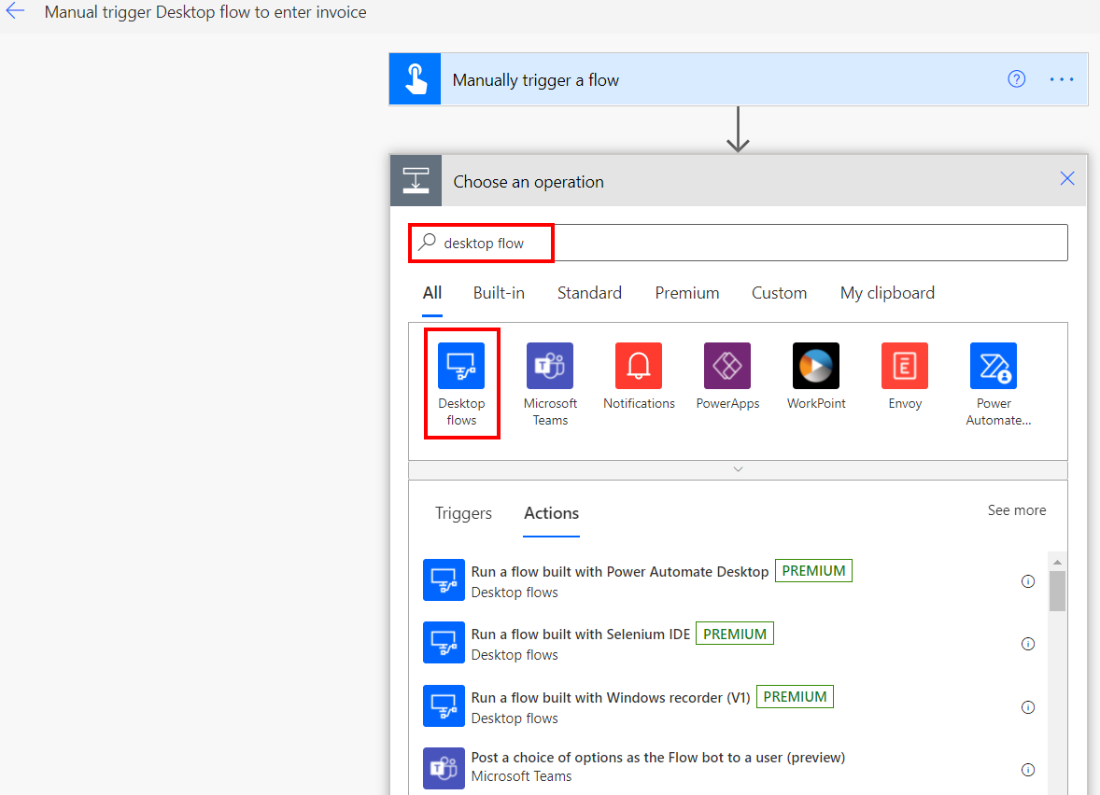

1. Select Run a flow built with Power Automate Desktop.

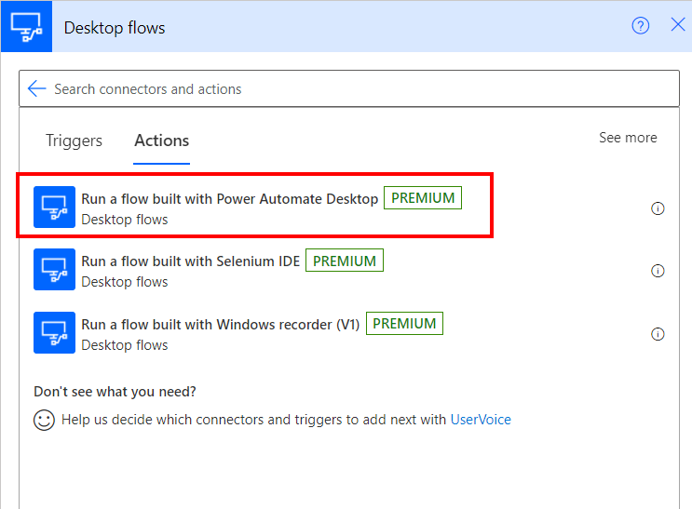

1. After you click the ellipsis icon, you’ll notice, that the connection reference you have created previously is automatically selected.

1. Under desktop flow, select Enter an invoice desktop flow that you have created in previous lab.

1. Under Run Model, select Attended – Runs when you’re signed in. This mode will run the desktop flow while you are signed in the same machine.

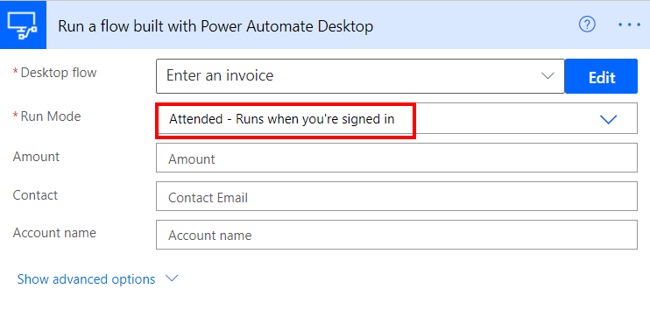

1. Fill the box with these input values: (note we are using static input values for now and will learn in next labs how to use dynamic input values)

* Amount: 200
* Contact: b.friday@wingtiptoys.com
* Account name: WingTip Toys

Then click Save.

1. Select Test at the top-right of the screen.

click test on top right corner of your screen

1. Select Manually. Then click Test.

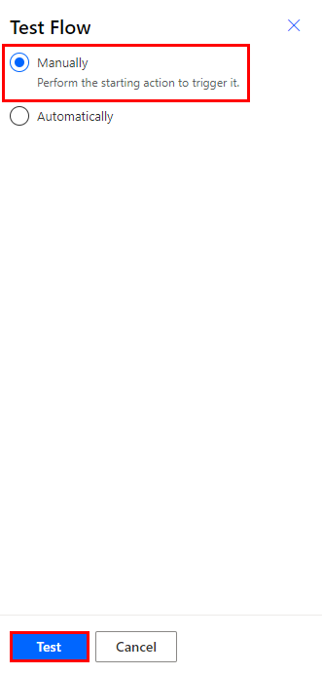

1. If you see a green check, you are ready to go. Click Continue.

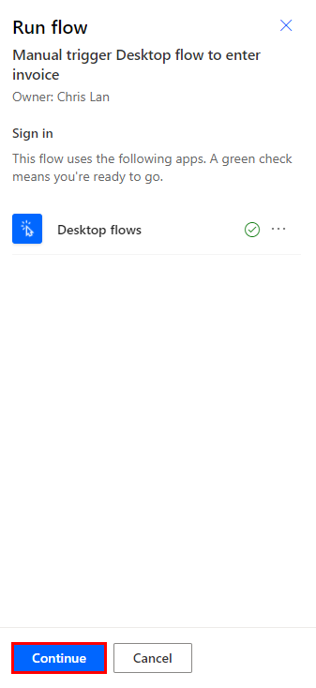

1. Click Run flow.

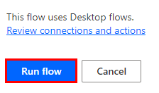

1. Click Done if your flow run successfully started.

**Note:** Do not interact with your device while testing.

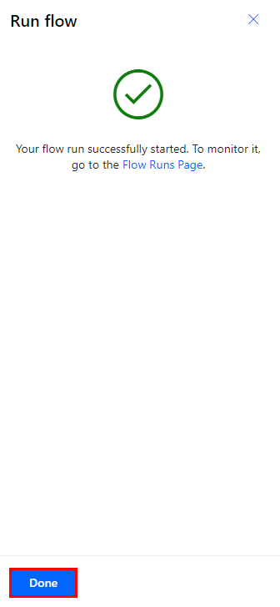

1. Watch your desktop flow will be triggered from the cloud and run on your desktop
2. After your flow has been run successfully, you will see the run detail page and the **Invoice ID** returned as the output value.

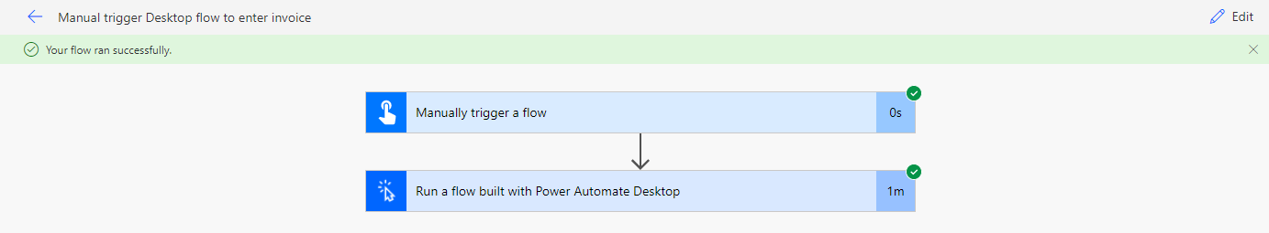

**Tip**: If the flow run failed at the desktop flow step, **always** go to the desktop flow page, click into the desktop flow just ran, and look up run history from there to see detail error messages. This will help you troubleshooting and fix the run.

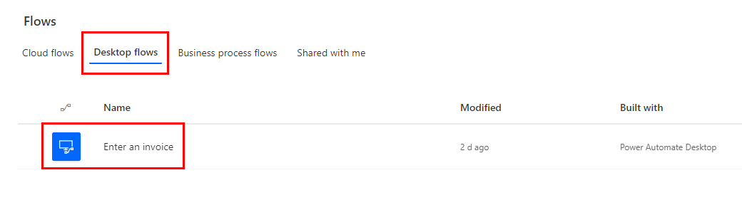

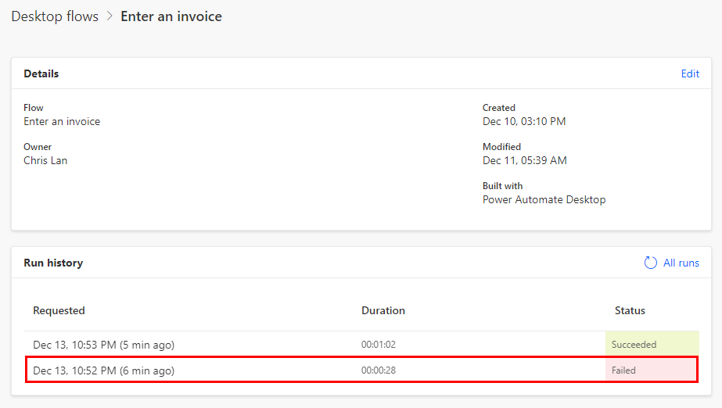

## Monitor the list of machines

Once a machine is registered to an environment, you can view its details at any time in Power Automate. You can also view all other machines that you have access to.

1. Open the test profile in a browser and navigate to <https://make.powerautomate.com/>.
2. Select Monitor, then select Machines.

Within the list, for each machine you can view:

* The name of the machine.
* The description of the machine.
* The version of the installed Power Automate Desktop software.
* The group that the machine is a part of, if applicable.
* The status of the machine.
* The number of flows running on the machine.
* The number of flows queued on the machine, if applicable.
* The type of access you have to the machine.
* The owner of the machine.

## Share a machine

You can share a machine with other users in your organization, giving those users specific permissions to access your machine.

1. Open the test profile in a browser and navigate to [powerautomate.microsoft.com](https://powerautomate.microsoft.com/).
2. Select Monitor, then select Machines.

1. Select your machine from the list.

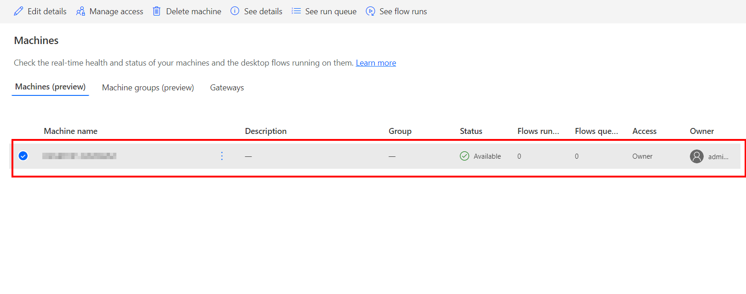

1. Select Manage access.

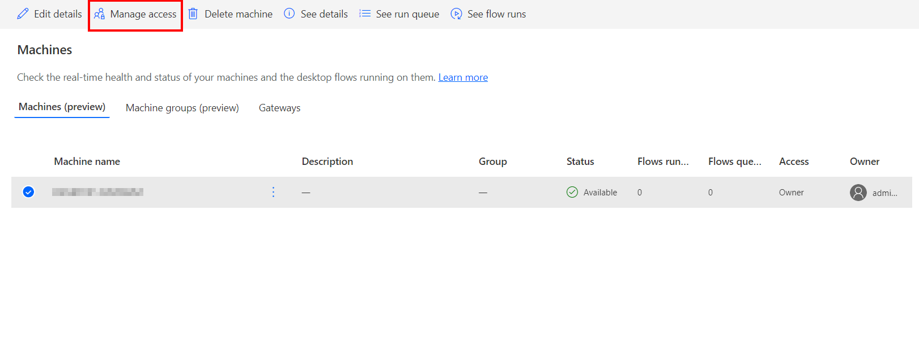

1. Select the Add people field, then enter the name of the person in your organization with whom you’d like to share the machine.

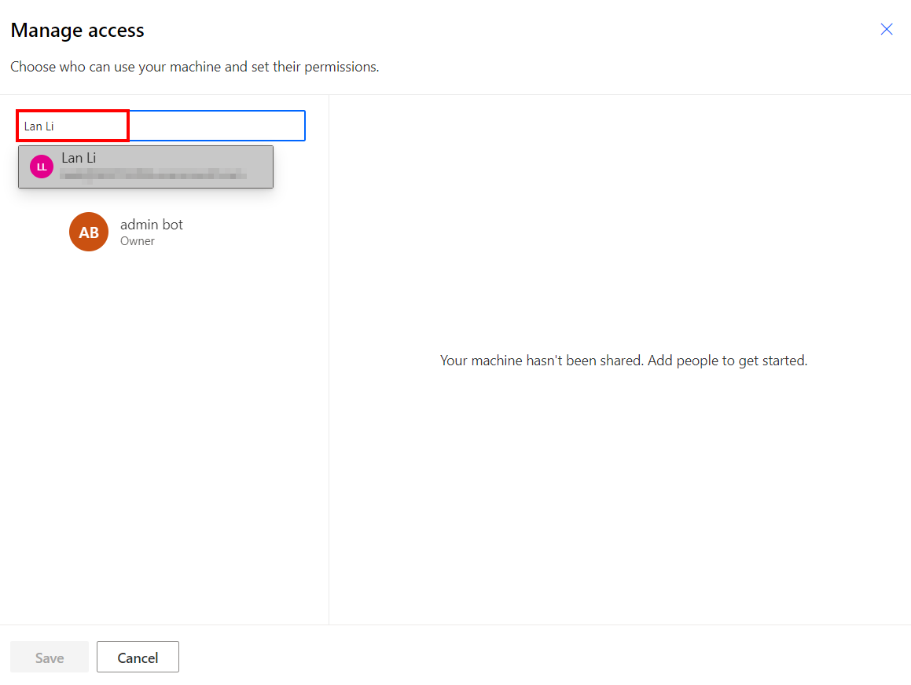

1. Select the name of the person to choose with which permissions they can access the machine.

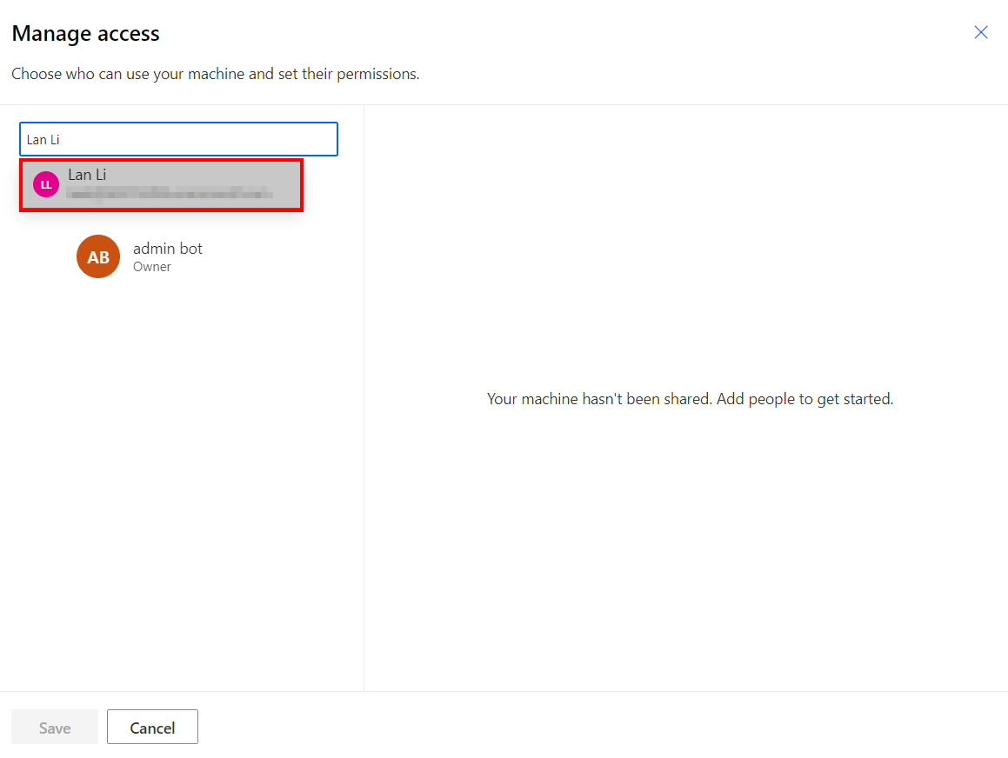

1. Click Save.

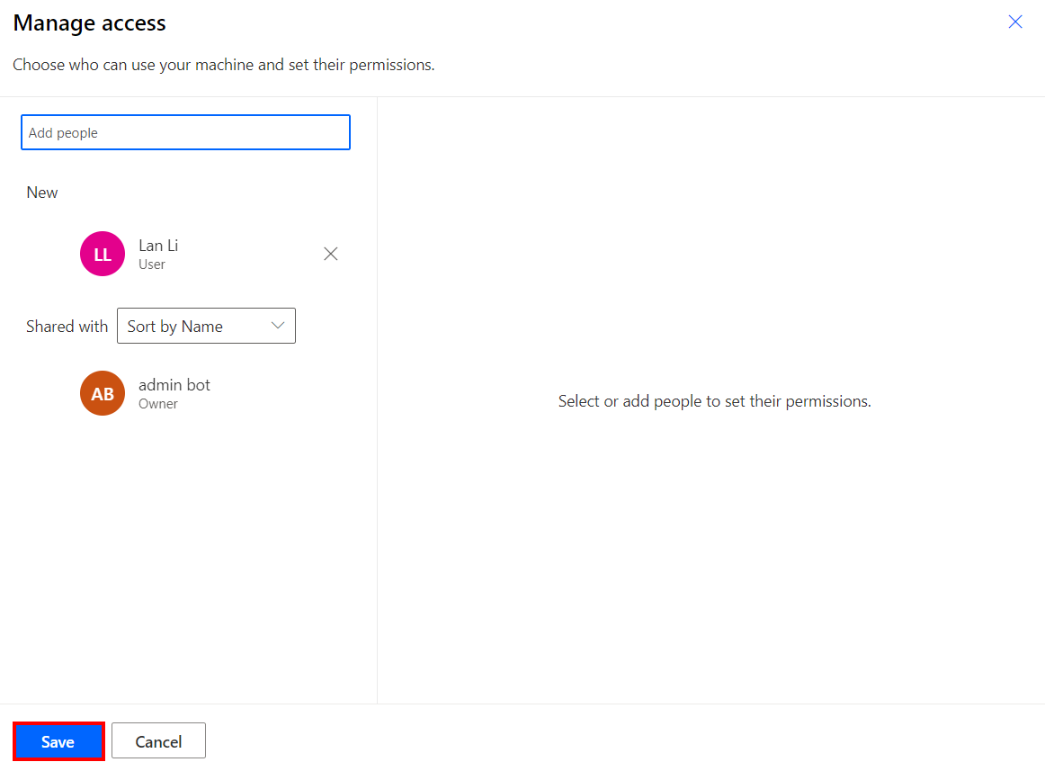

1. There are two levels of permissions that you can use when managing access to your machine:

* Co-owner: This access level gives full permissions to that machine. Co-owners can run desktop flows on the machine, share it with others, edit its details, and delete it.
* User: This access level only gives permission to run desktop flows on the machine. No edit, share, or delete permissions are possible with this access.

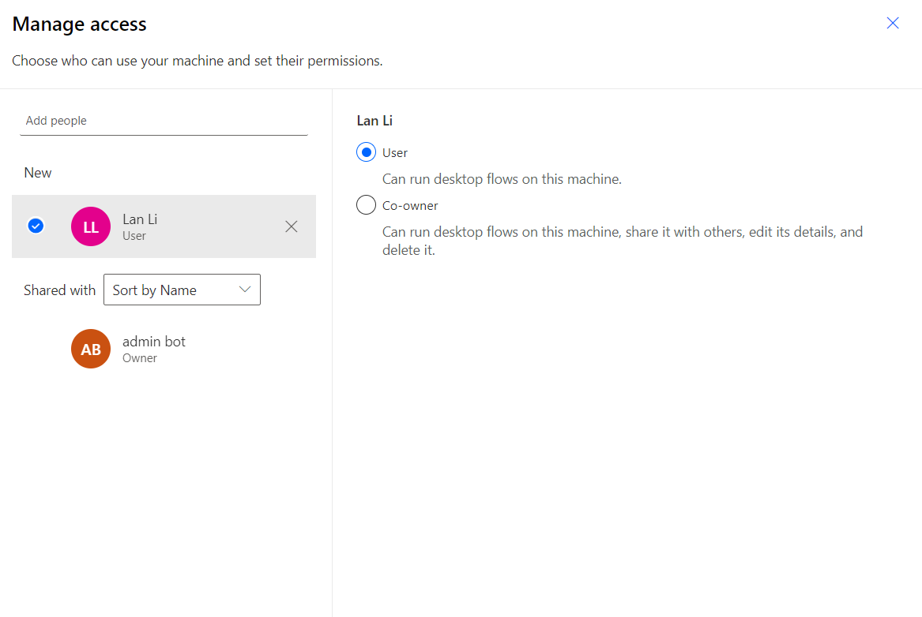

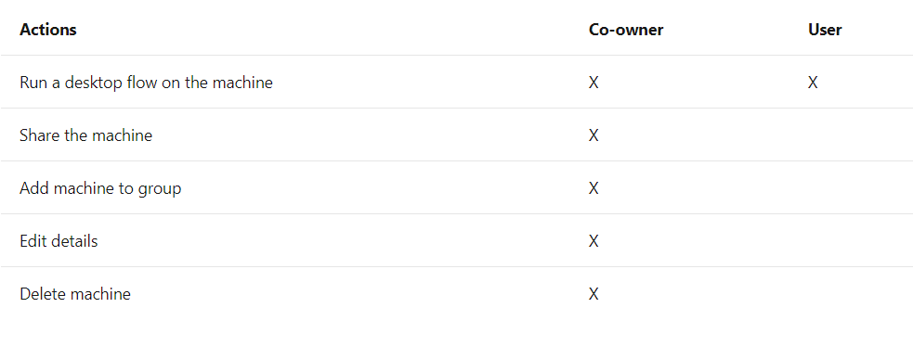Check your knowledge

**Lab 4**

7 mins

1. Users will need either an _______ or Desktop Flows Machine Owner role to register machines.
2. Environment Maker
3. Environment user
4. Environment Help
5. None of the above

Answer: A. Environment user

1. If the cloud flow run failed at the desktop flow step, always go to the desktop flow page, click into the desktop flow just ran, and look up Run history from there to see detail error messages. This will help you troubleshooting and fix the run.
2. True
3. False

Answer: A. True, you can find detail information about your desktop flow execution within the desktop flow Run history page.

1. When creating a connection to use the “Run a flow built with Power Automate Desktop” action, if you are not sure what to put in the domain and username field, you can use the Command Prompt window (open Start, type CMD and hit enter), type “_______” command to locate the Domain and Username.
2. Find user
3. Locate user
4. What’s my user
5. Set user

Answer: D. Set user

Information in this document, including URL and other Internet Web site references,  
is subject to change without notice. Unless otherwise noted, the example companies, organizations, products, domain names, e-mail addresses, logos, people, places, and events depicted herein are fictitious, and no association with any real company, organization, product, domain name, e-mail address, logo, person, place or event is intended or should be inferred. Complying with all applicable copyright laws is the responsibility of the user. Without limiting the rights under copyright, no part of this document may be reproduced, stored in or introduced into a retrieval system, or transmitted in any form or by any means (electronic, mechanical, photocopying, recording, or otherwise), or for any purpose, without the express written permission of Microsoft Corporation.

Microsoft may have patents, patent applications, trademarks, copyrights, or other intellectual property rights covering subject matter in this document. Except as expressly provided in any written license agreement from Microsoft, the furnishing of this document does not give you any license to these patents, trademarks, copyrights, or other intellectual property.

The names of manufacturers, products, or URLs are provided for informational purposes only and Microsoft makes no representations or warranties, either expressed, implied, or statutory, regarding these manufacturers or the use of the products with any Microsoft technologies.  
The inclusion of a manufacturer or product does not imply endorsement of Microsoft of the manufacturer or product. Links may be provided to third party sites. Such sites are not under the control of Microsoft and Microsoft is not responsible for the contents of any linked site or any link contained in a linked site, or any changes or updates to such sites. Microsoft is not responsible for webcasting or any other form of transmission received from any linked site. Microsoft is providing these links to you only as a convenience, and the inclusion of any link does not imply endorsement of Microsoft of the site or the products contained therein.

© 2021 Microsoft Corporation. All rights reserved.

Microsoft and the trademarks listed at https://www.microsoft.com/enus/legal/intellectualproperty/Trademarks/Usage/General.aspx  
are trademarks of the Microsoft group of companies. All other trademarks are property of their respective owners.